Specification Document- Library Project

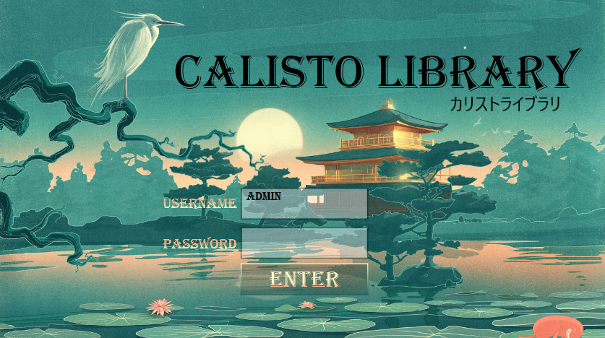

Overview

The application is a system for managing a bookstore or library at a basic level.

Features:

1.The system save information about a various items.

2.allow adding and editing the details of the items as well as displaying and sort them.

3.For each item, details such as the author, book publisher, genre, price etc…

4.buy specific item.

5.Borrow and return a specific item.

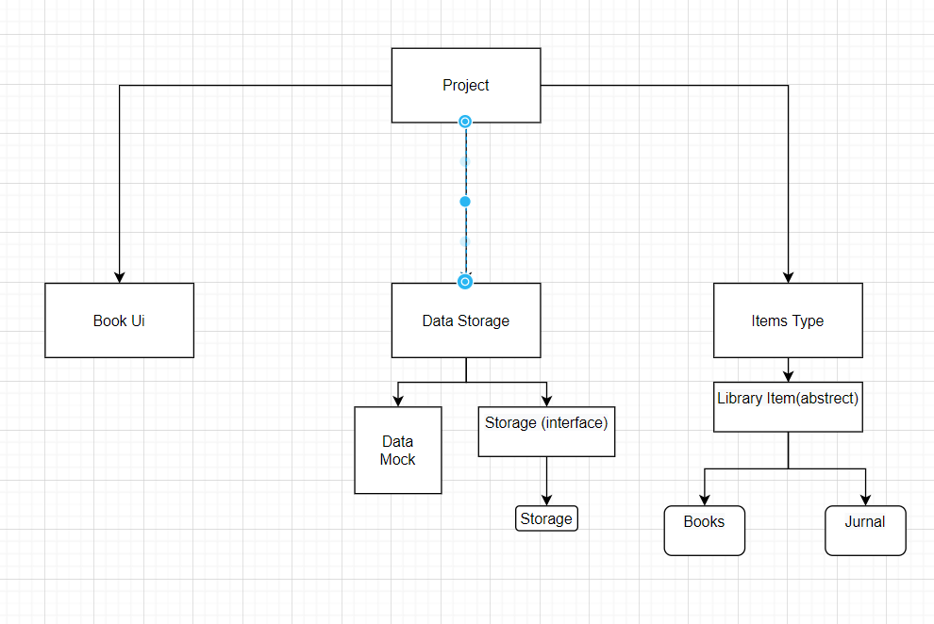Structure:

Pages

Main page:

The main page After entering the password, the user will reach the options page.

Option page:

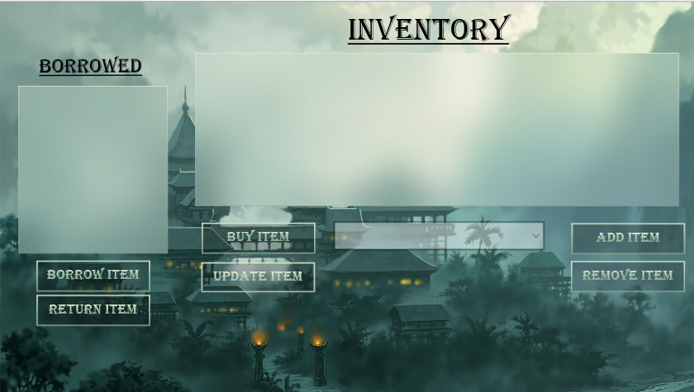The first page after the login page. In addition to displaying the objects in the list, this page is also used as the navigation system for the rest of the system pages

Add item page:

The page allows you to add a book or a magazine. On this page there are all the values ​​relevant to the object and they must be filled.

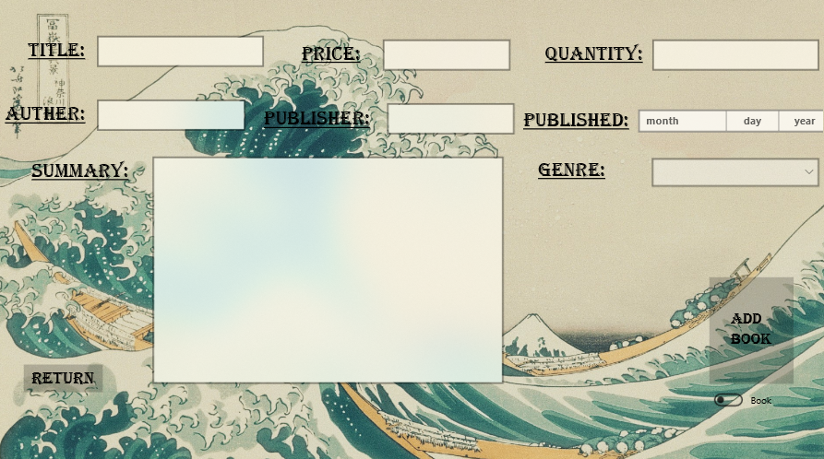

Update item page:

After selecting an object from the options page, the user will reach this page and see the details already entered and will be able to fill them in again.

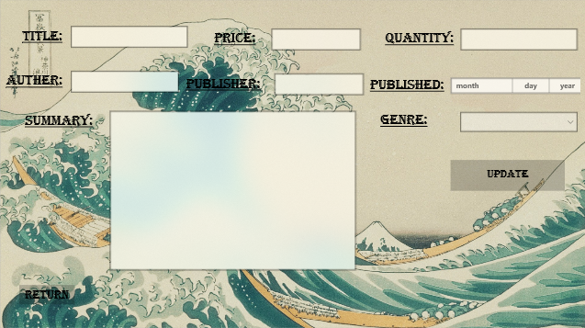

Info page:

After selecting an object from the options page, the user will reach this page and see a more expanded version of the values ​​of each object .

